ASP Core and Angular

Create Project Folder: There is a parent folder called DatingApp which contains two children folders: DatingApp.API and DatingApp-SPA

Mkdir DatingApp

cd DatingApp

dotnet new webapi –o DatingApp.API –n DatingApp.API

From DatingApp.API folder, type “code .” to open VS Code

## Install C# Extension Packages

* C# for Visual Studio Code (Powered by OmniSharp): syntax highlight
* C# Extensions: Folders color
* NuGet Package Manager

## Creating Database/Model in ASP Core Using Code Frist Approach

It is better to create a folder called Models, which contains all model classes, in the root folder DatingApp.API

Then create another folder called Data in the root folder to contain DataContext

Then create a class named DataContext:

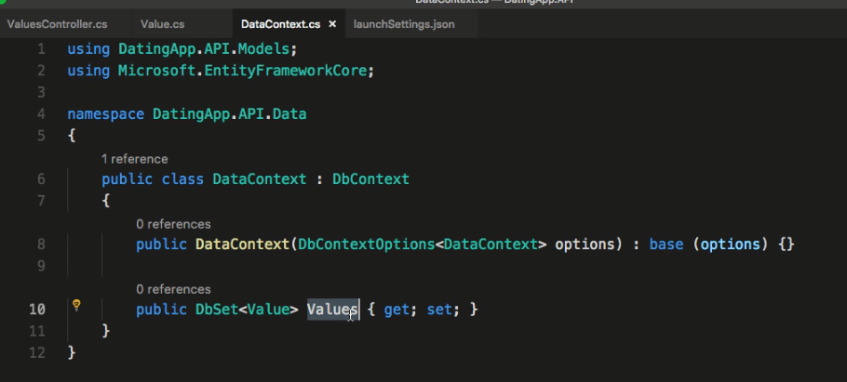

We need to let the app know that there is DataContext class by configuring in Startup.cs file. Adding a Service

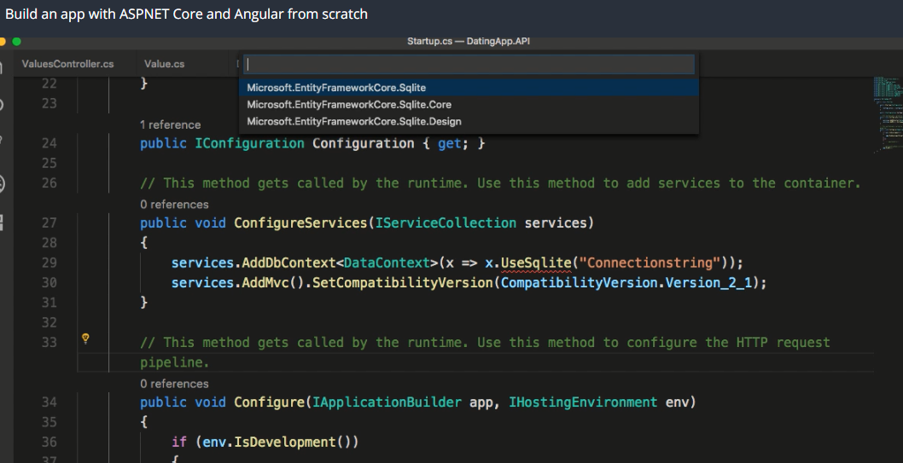

The Sqlite is part of Microsoft.Entity.FrameworkCore.Sqlite. Make sure to add the package to the app.

## Creating Angular App Using AngularCLI

First install Angular CLI by running : npm install –g @angular/cli@6.0.8 in the parent folder DatingApp

Then create angular project inside DatingApp: ng new DatingApp-SPA

Now we should have two projects: DatingApp.API and DatingApp-SPA

Installing More Angular Extensions

Angular Snippets, Angular Files, Angular Language Service, Angular2-switcher, AutoRename Tag, Bracket Pair Colorizer, Debugger for Chrome, Material Icon Theme, Path Intellisense, Prettier-Code Formatter, TSLint,